In this test, you have to prepare 3 specifications with 3-3 test cases, the reduction tables and small algorithms using the specification tool and the structogram tool. Prepare the solutions based on the patterns.
In the postcondition (of the specification), you should use the short form - and the algorithm needs to follow your specification.
Please look after the good, readable quality of your work.
There are 90 minutes available. For a good solution a maximum of 100 points could be reached. Don’t forget your name and Neptun-code! During work you are not allowed to talk (chat), to use cell phones, the internet, books, tutorials, ...
Remember! Cheating is not allowed, and action will be taken.
Create a pdf: File/Export/Create a pdf -> Upload in the TMS

Name: <write your name> Neptun code: <your neptun code>

1st task

Specification
In: n∈N, spellwords∈Tpl[1..n], Tpl=(word:S x correct:L)
Aux: cnt∈N
Out: corr∈S[1..cnt]
Pre: n>0
Post: (cnt, corr) = MIS(i=1..n, spellwords[i].correct, spellwords[i].word)

Link of the specification:
In: n∈N, spellwords∈Tpl[1..n], Tpl=(word:S x correct:L) Aux: cnt∈N Out: corr∈S[1..cnt] Pre: n>0 Post: (cnt, corr) = MIS(i=1..n, spellwords[i].correct, spellwords[i].word)

use SEARCH:
https://progalap.elte.hu/specifikacio/v1/?uuid=e8a974de-1e79-42b0-8a35-fac317d3cd40

Reduction table:
(cnt, y) = MIS(i=b..e, A(i), f(i))
(cnt, y) ~ (cnt, corr)
I ~ i
b..e ~ 1..n
A(i) ~ spellwords[i].correct
f(i) ~ spellwords[i].word

Test cases:
<Write your test cases (3) in the specification tool. The link of the spec.tool includes then it – but please, copy here, too>
1st test case | 2nd test case | 3rd test case
n: 5  spellwords: [{word: bired, correct: false},  {word: canyou, correct: false},  {word: card, correct: true},  {word: wter, correct: false},  {word: car, correct: true}]  cnt: 2  corr: [card, car] | n: 3  spellwords: [{word: direct, correct: false},  {word: good, correct: true},  {word: hello, correct: false}]  cnt: 1  corr: [good] | n: 4  spellwords:  [{word: wonder, correct: true},  {word: bad, correct: false},  {word: you, correct: false},  {word: I, correct: true}]  cnt: 2  corr: [wonder, I]

Algorithm
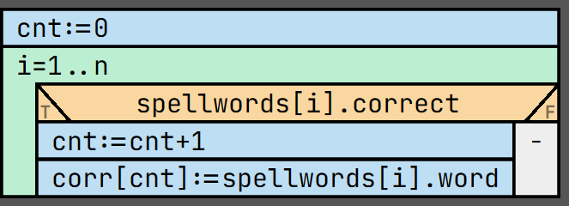

Link of the algorithm:
https://progalap.elte.hu/stuki/v1/?uuid=44017056-bc32-4d9c-8ca9-a560a16ea0f0

2nd task

Specification
In: n∈N, m∈N, conc∈N[1..n,1..m]
Aux: exists∈L
Out: loc∈N
Fn: increase: N -> L,
increase(j) = FORALL(i=1..n-1, conc[i,j]<conc[i+1,j])
Pre: n≥0 and m≥0 and ∀i∈[1..n]:(∀j∈[1..m]:(conc[i,j]≥0))
Post: (exists, loc) = SEARCH(j=1..m, increase(j))

Link of the specification:
https://progalap.elte.hu/specifikacio/v1/?uuid=ddfb45c2-57bd-482e-b9dd-93225bab25ec

Reduction table:
(exists, ind) = SEARCH(i=b..e,A(i))
(exists, ind) ~ (exists,loc)
i ~ j
b..e ~ 1..m
A(i) ~ increase(j)

all = FORALL(i=b…e, A(i))
all ~ output of increase()
i ~ i
b..e ~ 1..n-1
A(i) ~ conc[i,j]<conc[i+1,j]

Test cases:
<Write your test cases (3) in the specification tool. The link of the spec.tool includes then it – but please, copy here, too>
1st test case | 2nd test case | 3rd test case
n: 5  m: 3  conc:  [[ 1, 0, 0],  [ 1, 5, 1],  [ 1, 3, 2],  [ 0, 12, 3],  [ 1, 14, 5]]  exists: true  loc: 3 | n: 1  m: 3  conc:  [[12, 2, 0]]  exists: true  loc: 1 | n: 5  m: 1  conc:  [[ 2],  [ 5],  [4],  [12],  [14]]  exists: false  loc: 1

Algorithm
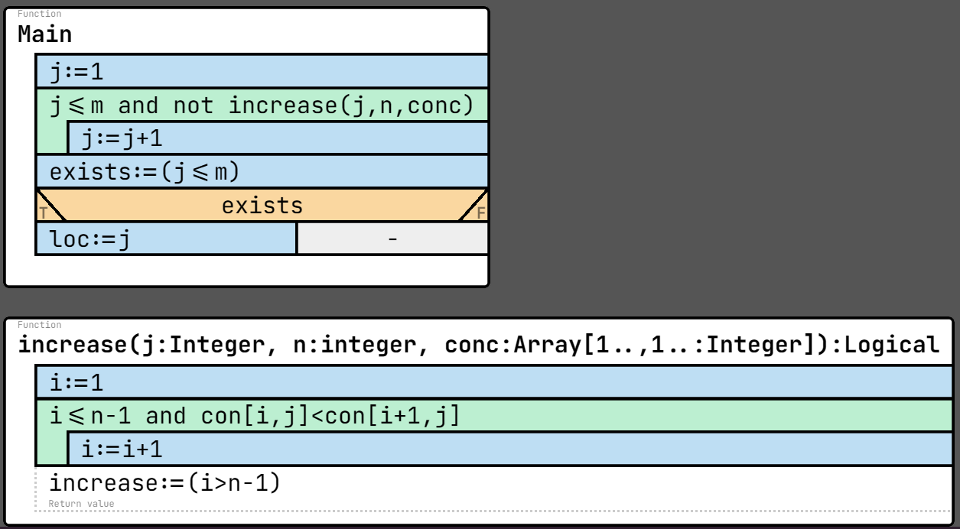

Link of the algorithm:
https://progalap.elte.hu/stuki/v1/?uuid=f48cf8dd-de59-468e-838f-21d0341fdb29

3rd task

Specification
In: n∈N, k∈N, ports∈S[1..n]
Aux: exists∈L
Out: kPort∈S
Fn: dtimes: N -> N,
dtimes(i) = COUNT(j=1..n, ports[j]=ports[i])
Pre: n≥0 and k≥0
Post: exists = EXISTS(i=1..n, dtimes(i)>k) and
exists -> kPort = "yes" and
not exists -> kPort = "no"

Link of the specification:
https://progalap.elte.hu/specifikacio/v1/?uuid=6e0f595e-7eff-47f2-afac-a125e99551fb

Reduction table:

<Write your test cases (3) in the specification tool. The link of the spec.tool includes then it – but please, copy here, too>
1st test case | 2nd test case | 3rd test case
n: 10  k: 3  ports: ["Shanghai",  "Singapore",  "Cape Town",  "Singapore",  "Honduras",  "Singapore",  "Honduras",  "Shanghai",  "Singapore",  "Cape Town"]  exists: true  kPort: yes | n: 6  k: 2  ports: ["Shanghai",  "Singapore",  "Honduras",  "Shanghai",  "Singapore",  "Cape Town"]  exists: false  kPort: no | n: 1  k: 0  ports: ["Shanghai"]  exists: true  kPort: yes

Algorithm
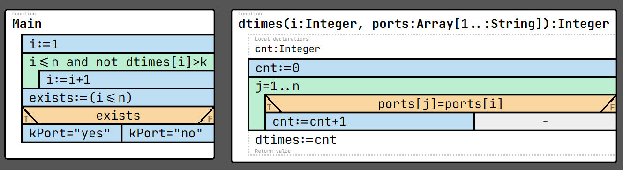

Link of the algorithm:
https://progalap.elte.hu/stuki/v1/?uuid=f21c9c27-7d52-4930-8ef1-69747ab1709b

